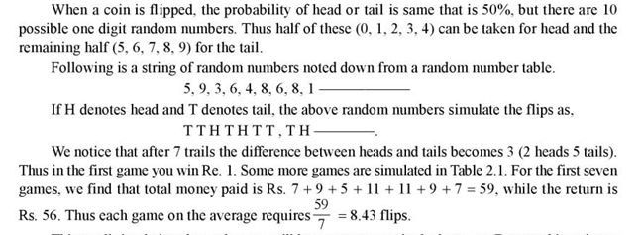
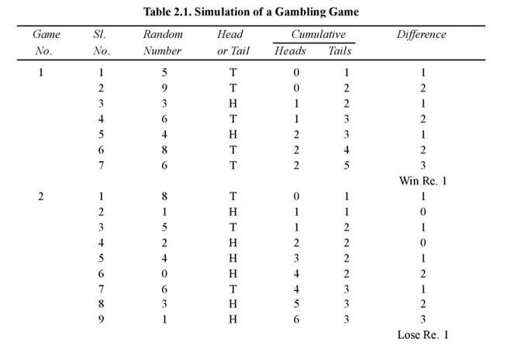
………………………………………………………………………………………………………………………………………..
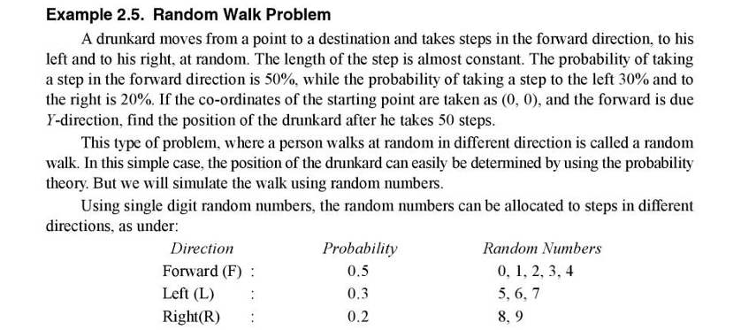
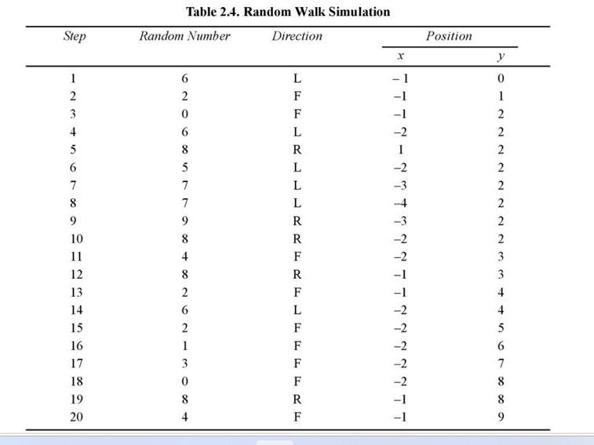
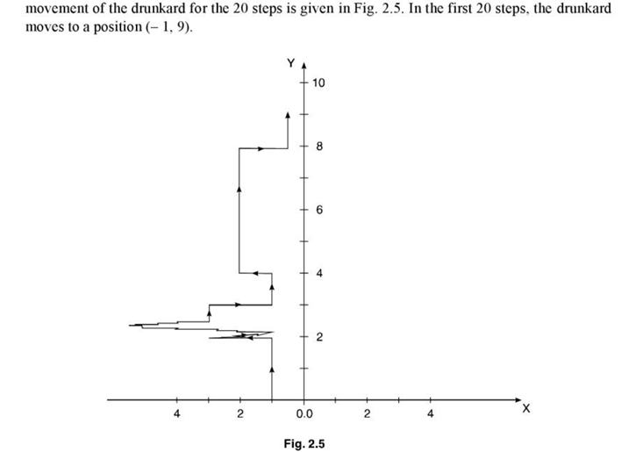
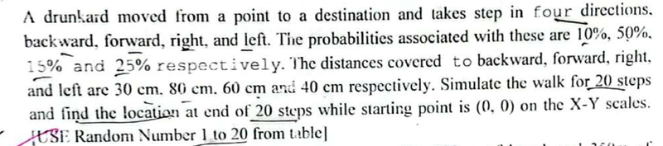
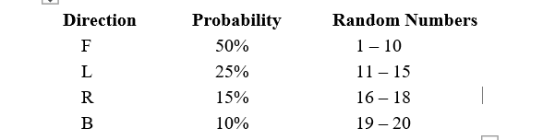
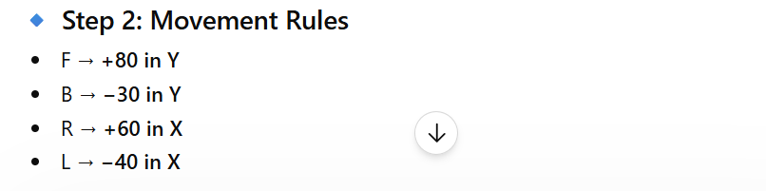
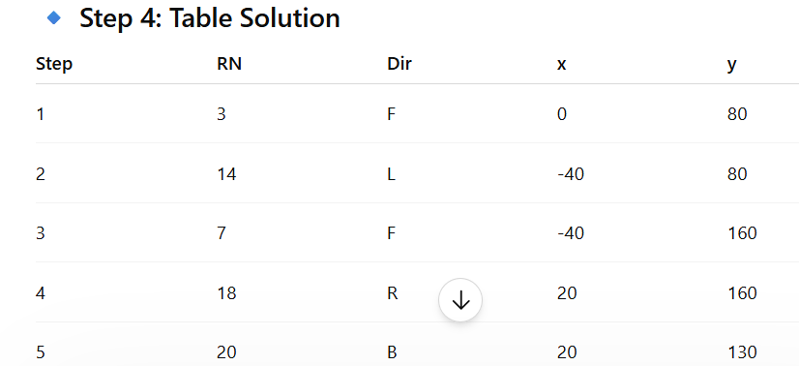


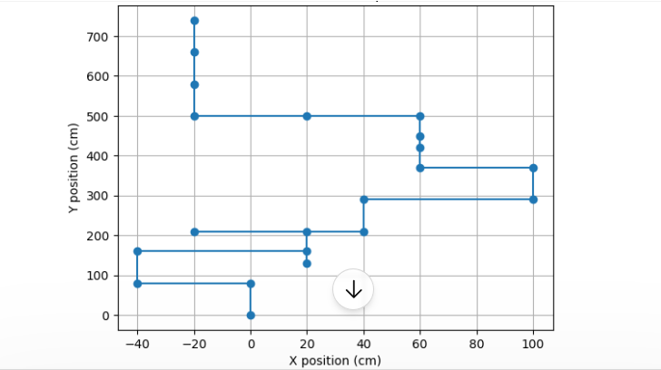
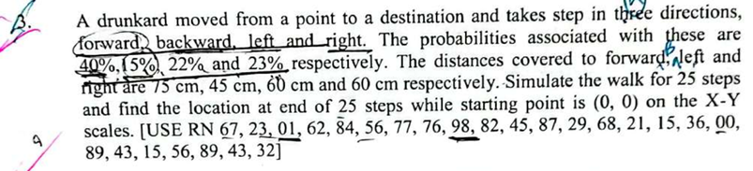
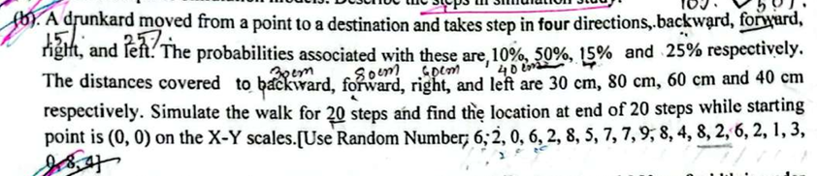
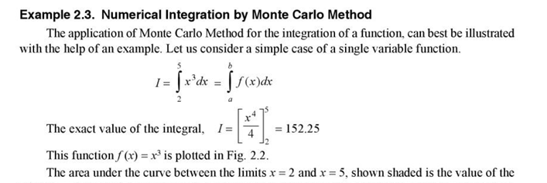
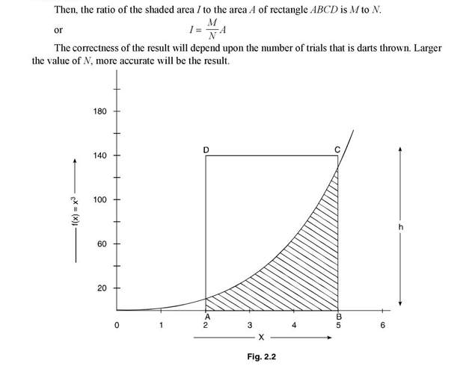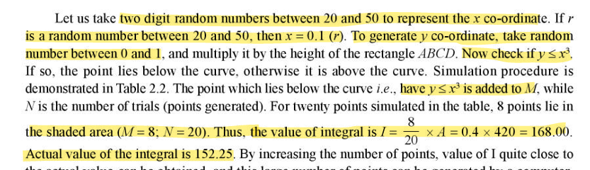
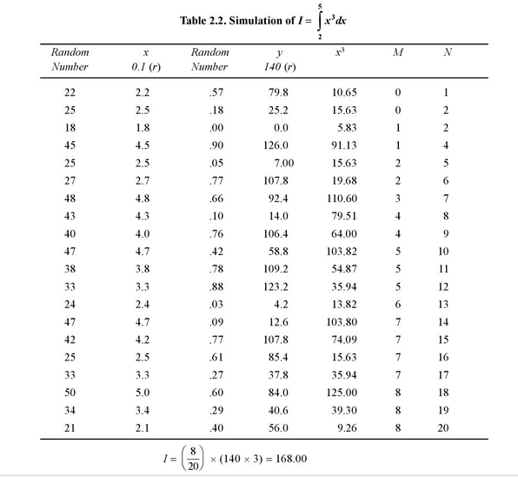
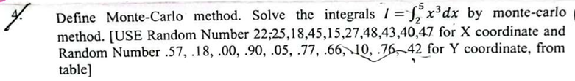
Do same style
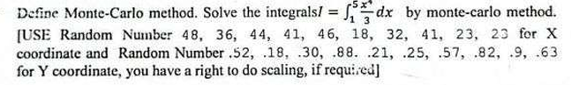
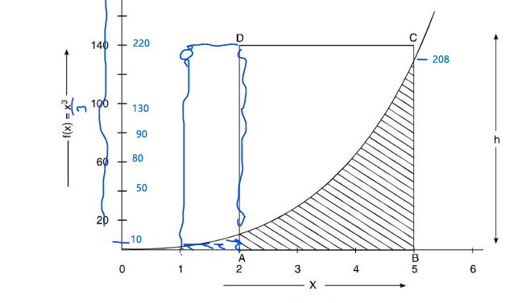
Do same style
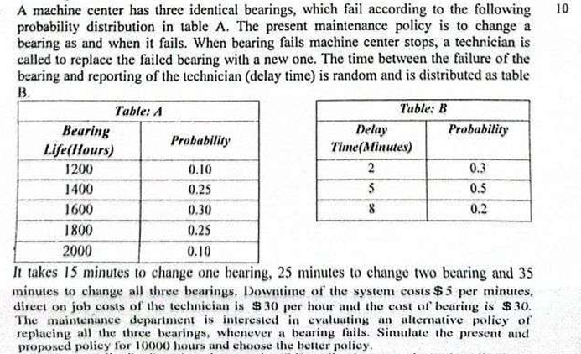
From the question I create 2 table :
Bearing Life (hours) | probability | Cumulative probability | Random Number
1200 | .10 | .10 | 01-10
1400 | .25 | .35 | 11-35
1600 | .30 | .65 | 36-65
1800 | .25 | .90 | 66-90
2000 | .10 | 1.00 | 91-00

Delay Time (minutes) | probability | Cumulative probability | Random Number
2 | .3 | .3 | 1-3
5 | .5 | .8 | 4-8
8 | .2 | 1.0 | 9-0

The present policy: we change only wasted bearing
Bearing 1 | Bearing 2 | Bearing 3

RD | Life | Clock | RD | Delay | RD | Life | Clock | RD | Delay | RD | Life | Clock | RD | Delay
05 | 1200 |  | 9 | 8 | 18 | 1400 |  | 0 | 8 | 29 | 1400 |  | 7 | 5
41 | 1600 |  | 8 | 5 | 63 | 1600 |  | 5 | 5 | 77 | 1800 |  | 0 | 8
86 | 1800 |  | 0 | 8 | 92 | 2000 |  | 5 | 5 | 10 | 1200 |  | 6 | 5
57 | 1600 |  | 5 | 5 | 05 | 1200 |  | 6 | 5 | 18 | 1400 |  | 2 | 2
29 | 1400 |  | 2 | 2 | 41 | 1600 |  | 5 | 5 | 63 | 1600 |  | 2 | 2
08 | 1200 |  | 3 | 2 | 86 | 1800 |  | 3 | 2 | 92 | 2000 |  | 7 | 5
34 | 1400 | 10400 | 7 | 5 | 57 | 1600 | 11000 | 2 | 2 | 05 | 1200 | 10600 | 2 | 2

Total delay = 35 | Total delay = 32 | Total delay = 29

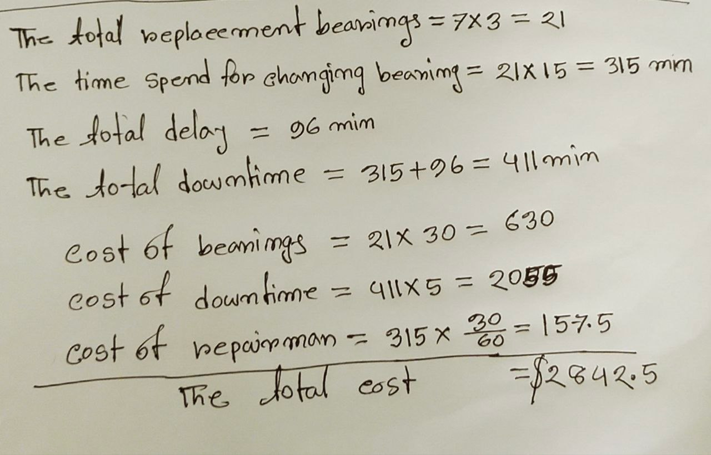
The proposed policy: we change all bearing when 1 or 2 or 3 are wasted
Bearing 1 life (hrs) | Bearing 2 life (hrs) | Bearing 3 life (hrs) | First failure(hrs) | Cumulated life (hrs) | RD | Delay (min)
1200 | 1400 | 1200 | 1200 |  | 1 | 2
1800 | 1200 | 1200 | 1200 |  | 6 | 5
1400 | 1600 | 1400 | 1400 |  | 3 | 2
2000 | 1400 | 1200 | 1200 |  | 9 | 8
1600 | 1800 | 1400 | 1400 |  | 4 | 5
1200 | 1400 | 1600 | 1200 |  | 7 | 5
1800 | 2000 | 1400 | 1400 |  | 2 | 2
1600 | 1200 | 1800 | 1200 | 10200 | 8 | 5

Total delay = 34

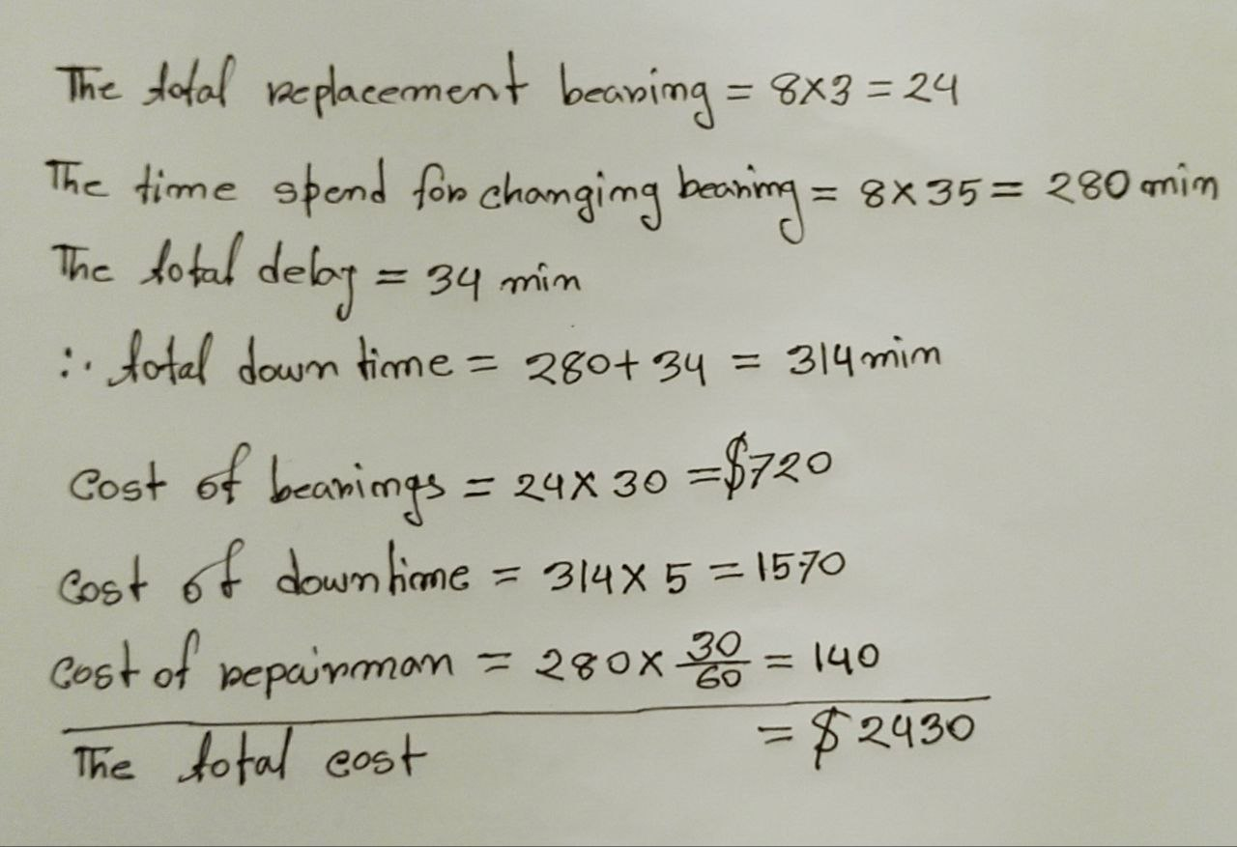
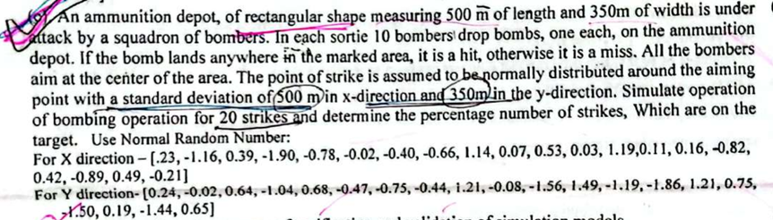
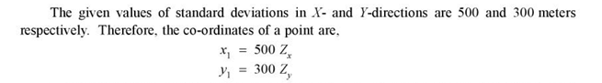
(X, Y) = (500, 350) ar moddhe porle hit.
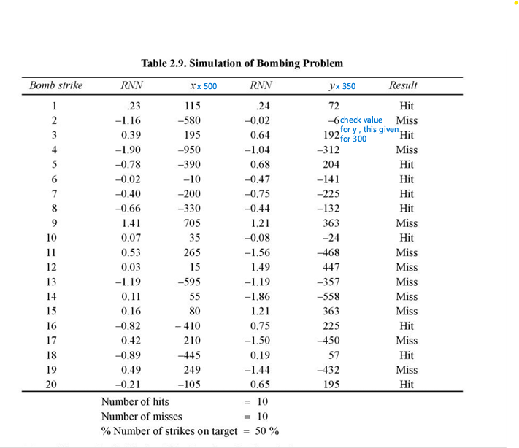
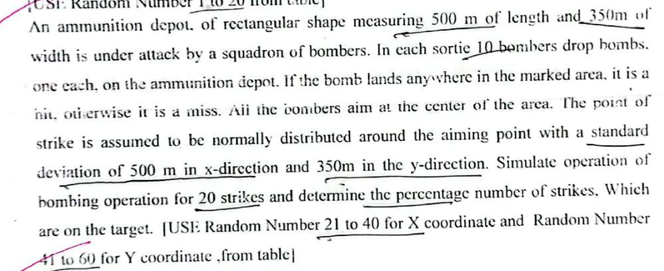
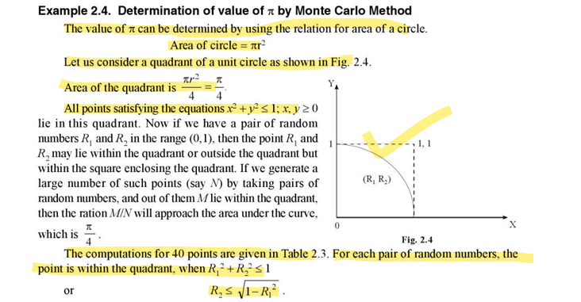
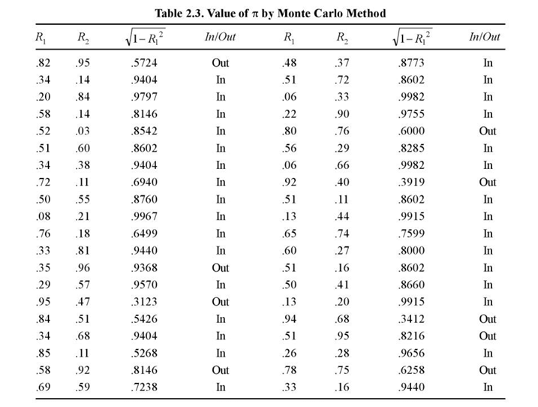
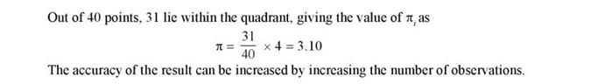
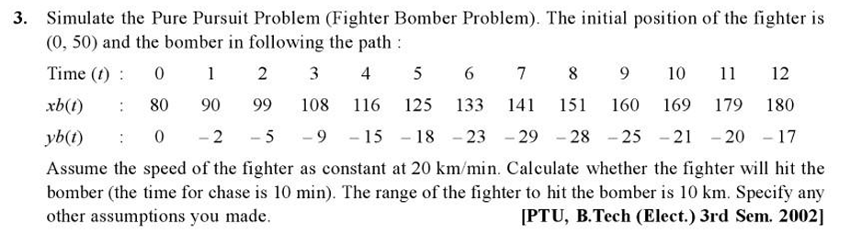
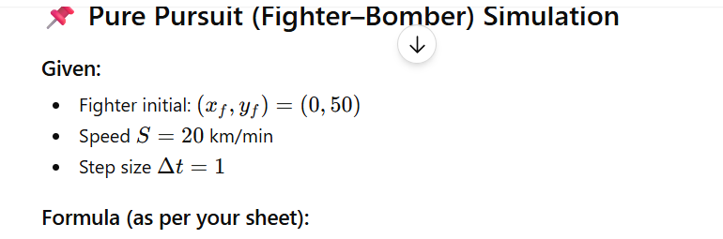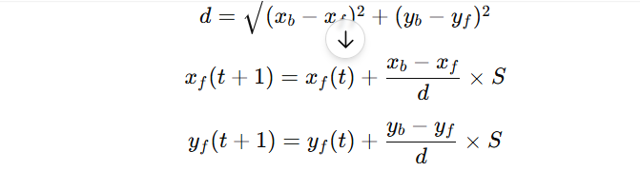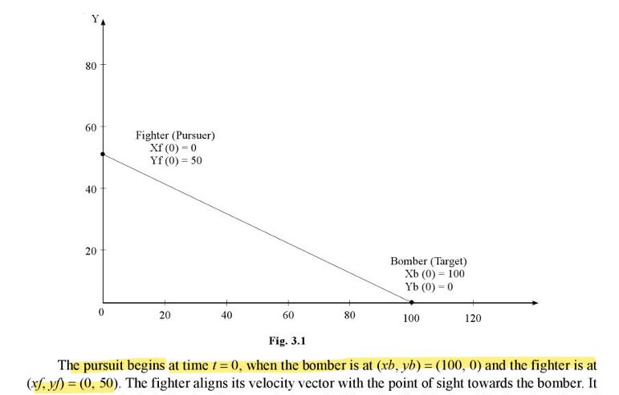
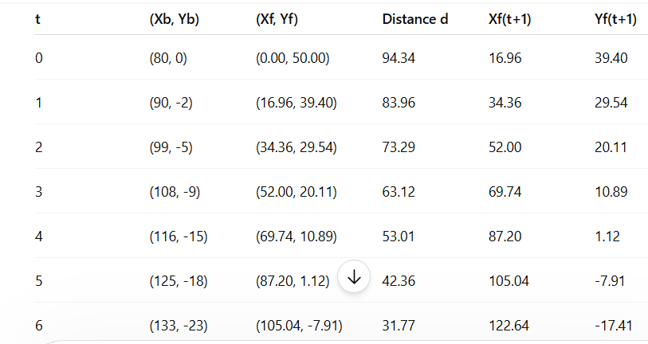
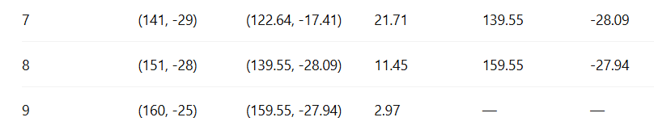
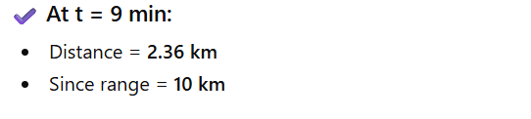
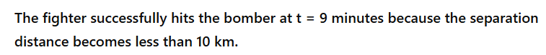
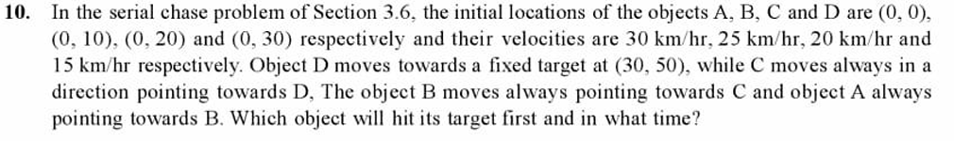

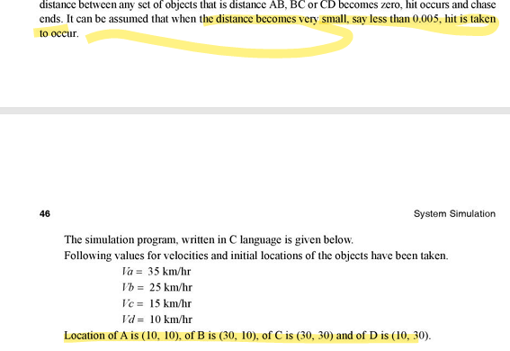
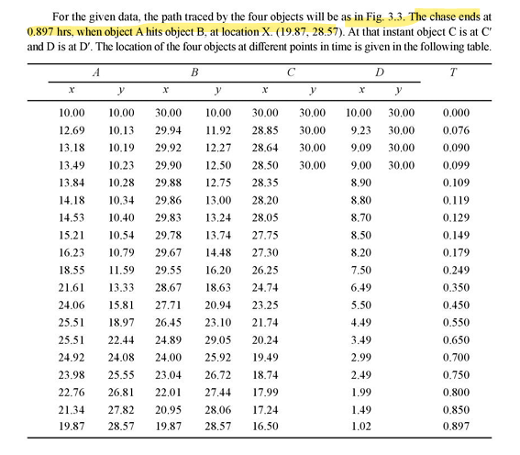
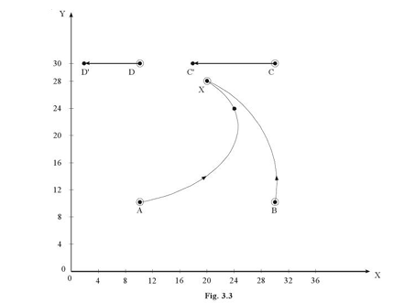

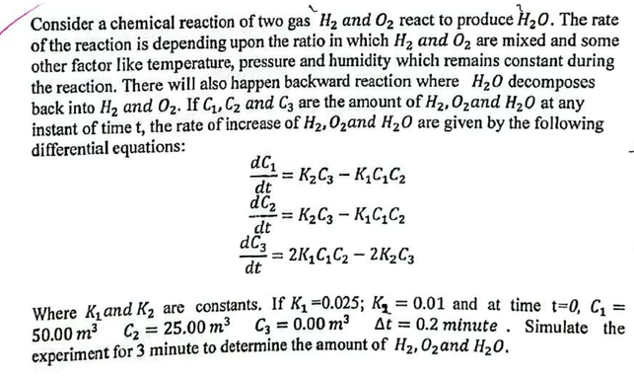
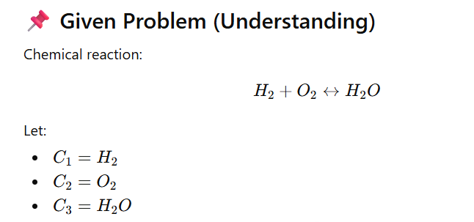
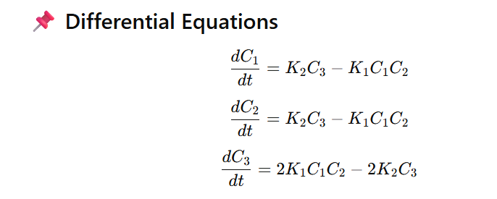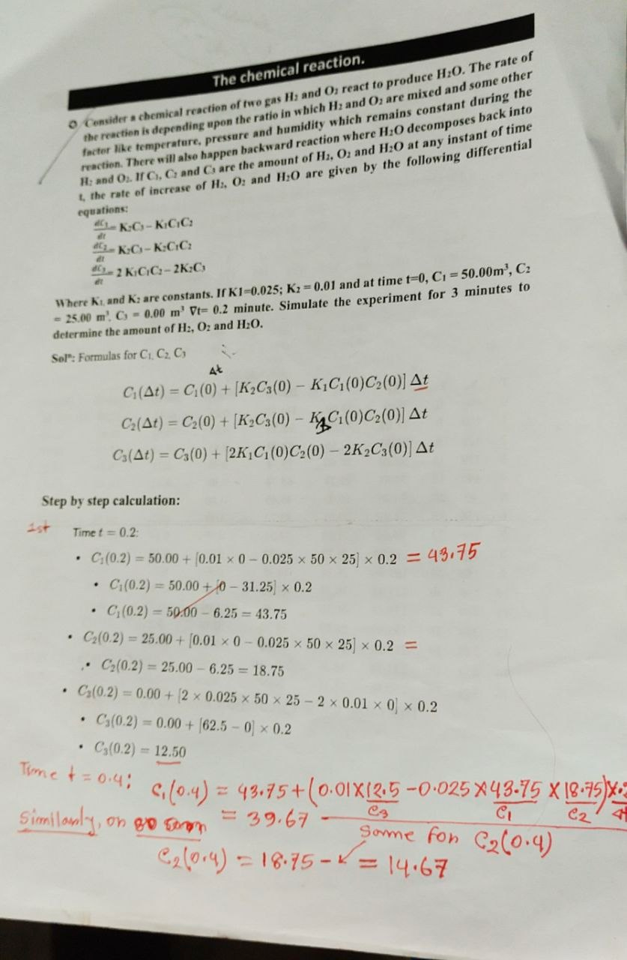
t (min) | C₁ | C₂ | C₃
0.0 | 50.000 | 25.000 | 0.000
0.2 | 43.750 | 18.750 | 12.500
0.4 | 39.673 | 14.673 | 20.653
0.6 | 36.805 | 11.805 | 26.391
0.8 | 34.660 | 9.660 | 30.680
1.0 | 32.987 | 7.987 | 34.026
1.2 | 31.642 | 6.642 | 36.716
1.4 | 30.536 | 5.536 | 38.928
1.6 | 29.610 | 4.610 | 40.780
1.8 | 28.823 | 3.823 | 42.354
2.0 | 28.147 | 3.147 | 43.706
2.2 | 27.560 | 2.560 | 44.880
2.4 | 27.046 | 2.046 | 45.908
2.6 | 26.592 | 1.592 | 46.816
2.8 | 26.189 | 1.189 | 47.622
3.0 | 25.829 | 0.829 | 48.342
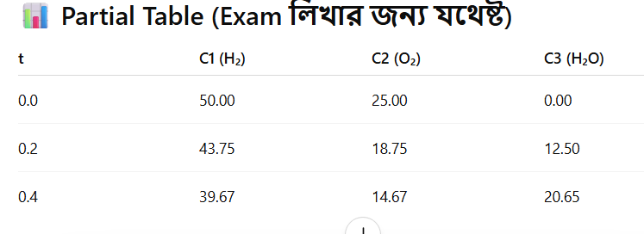
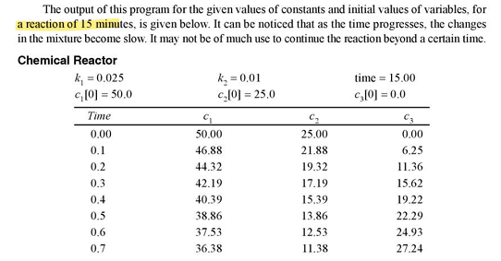
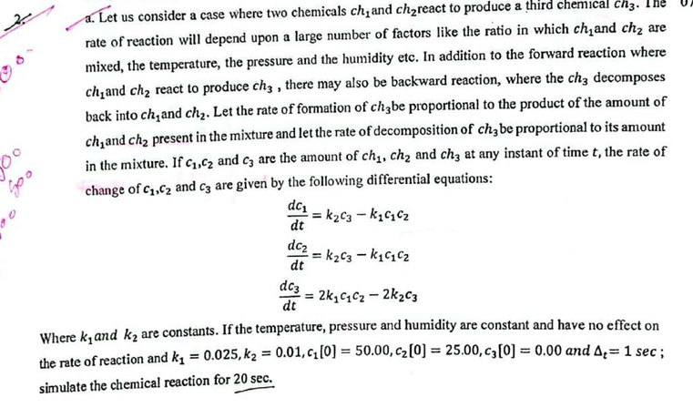
t (sec) | C₁ | C₂ | C₃
0 | 50.000 | 25.000 | 0.000
1 | 18.750 | -6.250 | 62.500
2 | 21.094 | -3.906 | 57.812
3 | 19.034 | -5.966 | 61.932
4 | 20.838 | -4.162 | 58.324
5 | 19.250 | -5.750 | 61.500
6 | 20.640 | -4.360 | 58.720
7 | 19.410 | -5.590 | 61.180
8 | 20.470 | -4.530 | 59.060
9 | 19.530 | -5.470 | 60.940
10 | 20.350 | -4.650 | 59.300
11 | 19.620 | -5.380 | 60.760
12 | 20.270 | -4.730 | 59.460
13 | 19.690 | -5.310 | 60.620
14 | 20.210 | -4.790 | 59.580
15 | 19.740 | -5.260 | 60.520
16 | 20.160 | -4.840 | 59.680
17 | 19.780 | -5.220 | 60.440
18 | 20.120 | -4.880 | 59.760
19 | 19.810 | -5.190 | 60.380
20 | 20.090 | -4.910 | 59.820

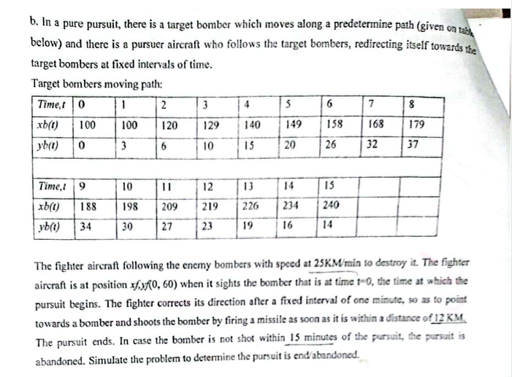
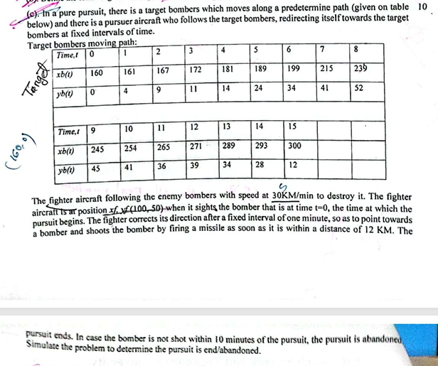
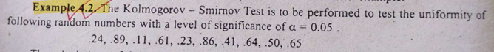
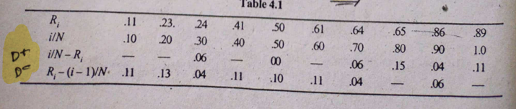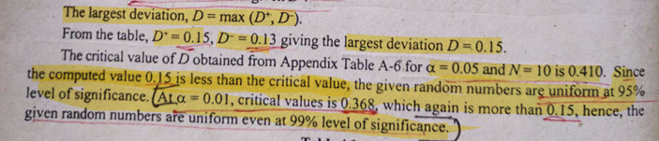
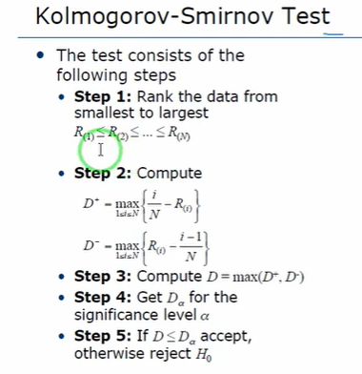
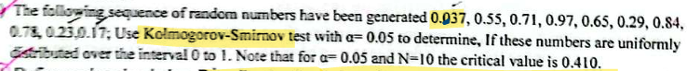
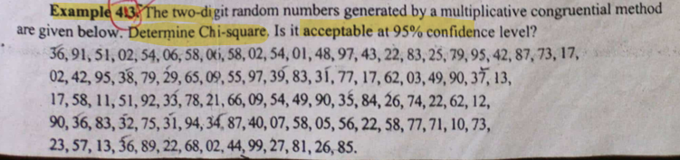
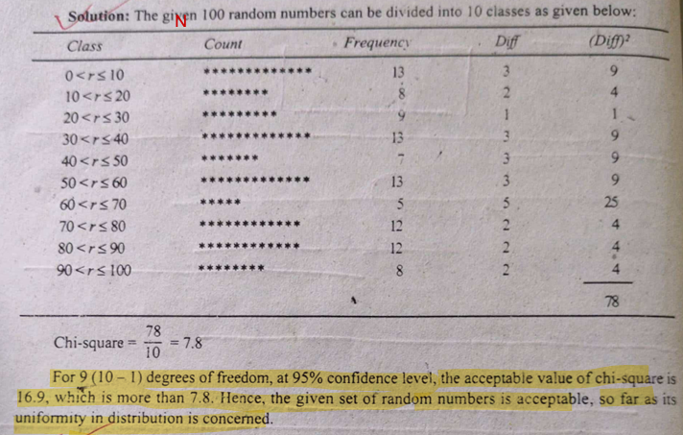
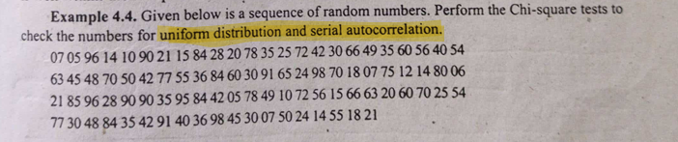
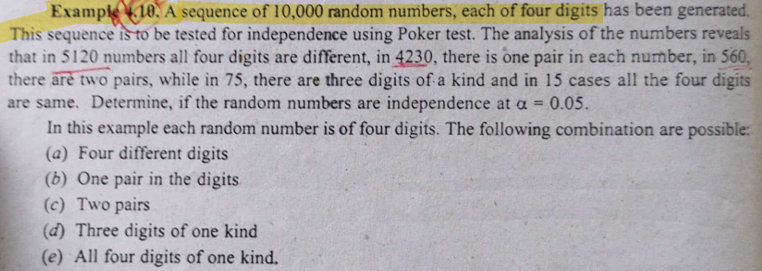
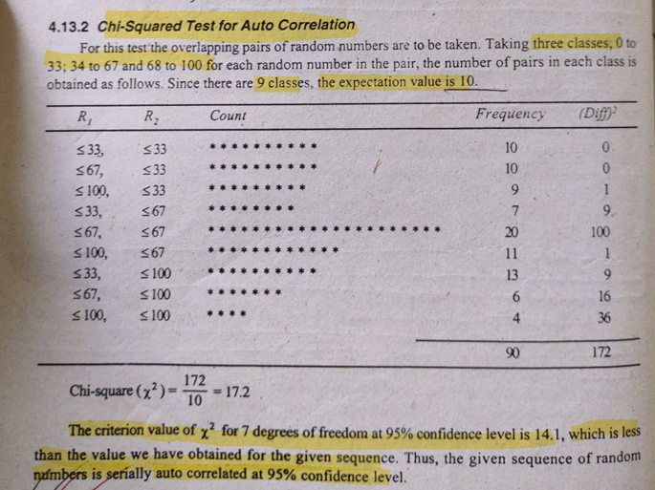
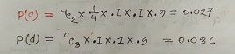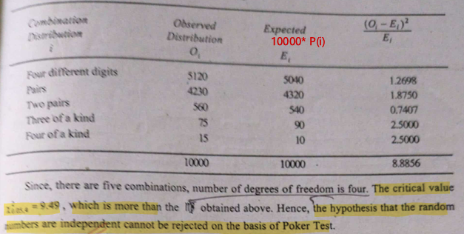

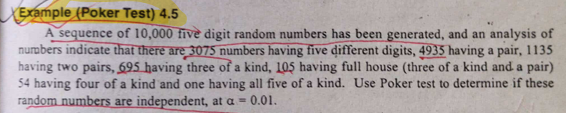
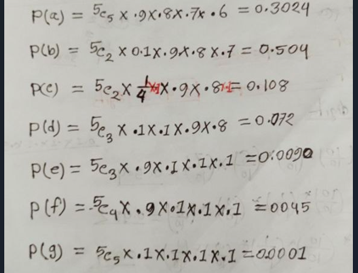
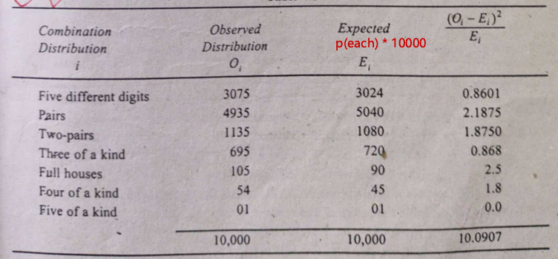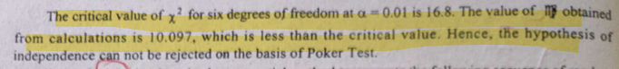

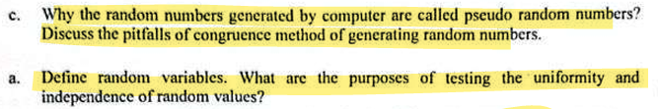
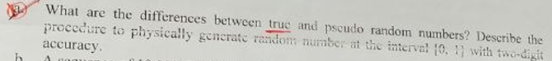
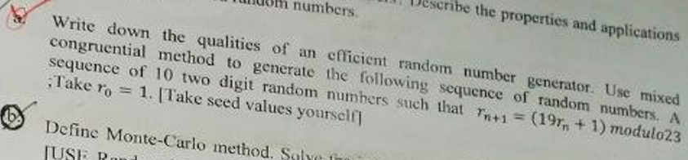

1. Define computer simulation models. Write down the qualities of an efficient random number generator.
Answer:
Computer Simulation Model:
A simulation model is a representation of a system developed using mathematical and logical relationships, which is executed on a computer to study the behavior of the system.
Qualities of a Good Random Number Generator:
- The numbers should be uniformly distributed over (0,1)
- The numbers should be statistically independent
- The generator should have a long period
- It should be reproducible
- It should be computationally efficient
- It should require minimum storage

2. Define the simulation of continuous system. Describe the disadvantages of analog simulation.
Answer:
Continuous System Simulation:
A continuous system is one in which the state variables change continuously with respect to time. The simulation of such systems is carried out by solving differential equations using numerical methods.
Disadvantages of Analog Simulation:
- Low accuracy compared to digital simulation
- Presence of noise and drift
- Difficult to modify the model
- Limited flexibility
- High cost of equipment

3. Why are the random numbers generated by computer called pseudo random numbers? Discuss the pitfalls of congruential method.
Answer:
Pseudo Random Numbers:
The random numbers generated by a computer are called pseudo random numbers because they are generated by deterministic procedures and hence are not truly random.
Pitfalls of Congruential Method:
- Short period if parameters are not properly chosen
- Serial correlation between numbers
- Possibility of non-uniform distribution
- Generation of repeating patterns
- Poor choice of constants leads to bad randomness

4. Define random variables. What are the purposes of testing the uniformity and independence of random values?
Answer:
Random Variable:
A random variable is a variable which takes different values as a result of outcomes of a random experiment.
Purpose of Testing:
- Uniformity Test: To ensure that the numbers are uniformly distributed in (0,1)
- Independence Test: To ensure that the numbers are not correlated with each other

5. Define auto-correlation.
Answer:
Auto-correlation is a measure of the relationship between the elements of a sequence of random numbers separated by a fixed interval (lag). It is used to test the independence of random numbers.

6. Define the following: (i) Arrival rate (ii) Service rate
Answer:
- Arrival Rate (λ): The average number of entities arriving per unit time
- Service Rate (μ): The average number of entities served per unit time

7. Define distributed simulation. Write down the difference between Monte Carlo and stochastic simulation.
Answer:
Distributed Simulation:
Distributed simulation is a simulation in which the model is executed on multiple processors or computers to reduce execution time and increase efficiency.
Monte Carlo Simulation (Definition):
A technique that uses repeated random sampling to obtain numerical results for problems that may be deterministic in nature.
Stochastic Simulation (Definition):
A simulation where the system behavior is governed by random variables and evolves over time.
Feature | Monte Carlo Simulation | Stochastic Simulation
Nature | Static | Dynamic
Time | Not time-dependent | Time-dependent
Application | Mathematical problems | Real-life systems

8. What are normally distributed random numbers? Describe their applications.
Answer:
Normally Distributed Random Numbers:
These are random numbers which follow the normal distribution characterized by mean (μ) and standard deviation (σ), forming a bell-shaped curve.
Applications:
- Modeling of measurement errors
- Representation of natural phenomena
- Statistical analysis
- Quality control

9. Define analog simulation. Describe the simulation of an exterior ballistics with an example.
Answer:
Analog Simulation:
Analog simulation is a technique in which one physical system is used to represent another system.

10. Define simulation. Describe the applications of simulation in computer science.
Answer:
Simulation:
Simulation is the process of designing a model of a real system and conducting experiments with this model for understanding system behavior.
Applications:
- Computer networks
- Operating systems
- Database systems
- Artificial intelligence
- Traffic systems

11. What do you mean by system simulation? Write down the properties of random numbers.
Answer:
System Simulation:
System simulation is the imitation of the operation of a real system over time using a model.
Properties of Random Numbers:
- Uniform distribution
- Independence
- Long period
- No correlation

12. What are the limitations of mid-square method?
Answer:
- The sequence repeats quickly
- It may generate zero values frequently
- It has a short period
- Poor statistical properties
- Not suitable for large simulations

13. What are the differences between true and pseudo random numbers?
Answer:

True Random Numbers:
True random numbers are numbers generated from natural or physical processes and are completely unpredictable.

Pseudo Random Numbers:
Pseudo random numbers are numbers generated by a deterministic mathematical algorithm using an initial value (seed), which appear random but are not truly random.

Feature | True Random Numbers | Pseudo Random Numbers
Nature | Truly random | Deterministic
Predictability | Unpredictable | Predictable
Speed | Slow | Fast
Reproducibility | Not possible | Possible

